**Practical 7**

|  |  |
| --- | --- |
| Roll No. 23 | Name: Siddharth Pandya |
| Program: B-Tech (CSBS) | Division: CSBS |
| Batch: B2 | Date of Experiment: 5/9/20 |
| Date of Submission: 5/9/20 | Grade: |

**(PART – A)**

***Aim: To develop a turing machine.***

**Outcome:** After successfully competing of this practical, students will be able to learn:

* What is turing machine?
* How it works?
* How to convert Turing machine to unrestricted grammar?

**A.1 Reading**

Read Page 70 to 102 of lab manual.

**A.2 Tasks**

1. Develop a single tape turing machine for the language L = {anbncn} for n > 0 using JFLAP tool.

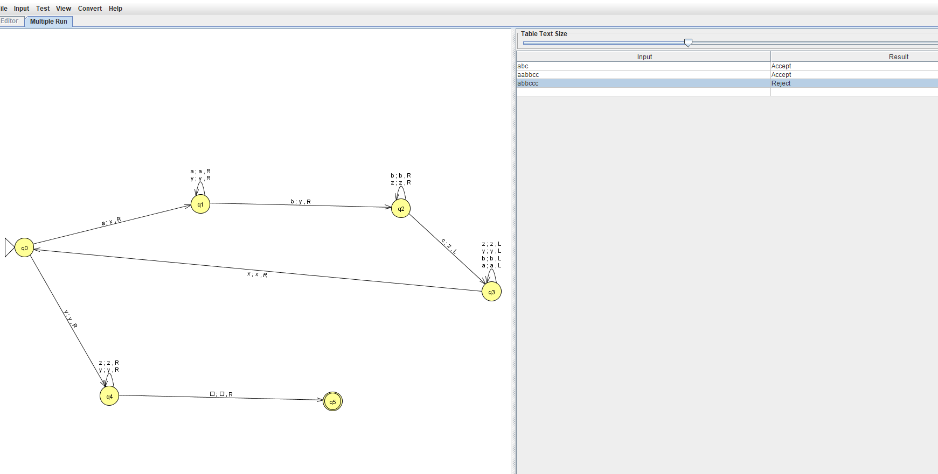

1. Convert it to unrestricted grammar using JFLAP tool.

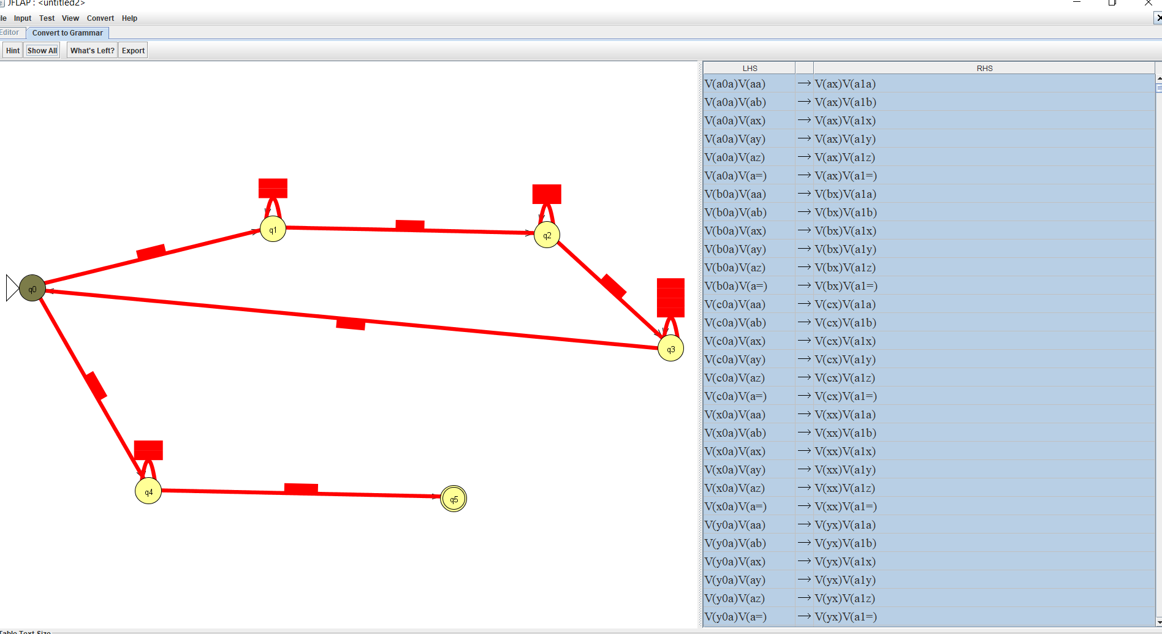

**PART B**

(PART B: TO BE COMPLETED BY STUDENTS)

**(Students must submit the soft copy as per following segments within two hours of the practical. The soft copy must be uploaded on the Portal or emailed to the concerned lab in charge faculties at the end of the practical in case the there is no portal access available)**

**B.1 Output:**

1. Write a procedure to generate the Turing machine using JFLAP tool.e

1) Open Jflap tool.

2) Select Turing Machine

3) Create the number of states using state creator

4) Connect the required states with transition creator

5)After turing machine is build, Click on input and then click on multiple run.

6) Put the values to check

2.Write a procedure to convert turing machine to unrestricted grammar using the JFLAP tool.

1. After the turing machine is made, Go on Convert.
2. Click on Convert to unrestricted grammar
3. Click on show all

**B.2 Observations/Learning**

*(Students are supposed to write the logic of constructed DFA and generated regular expression)*

We we were able to construct a single tape turing machine and able to convert it to unregistered grammar and learned how to make turing machine.

**B.3 Conclusion:**

*(Students must write the conclusion as per the attainment of individual outcomes and learning/observation)*

Turing machine was made and successfully converted to unregistered grammar.